# Madilyn Carpenter

# Assignment 10.2

Default todo app:

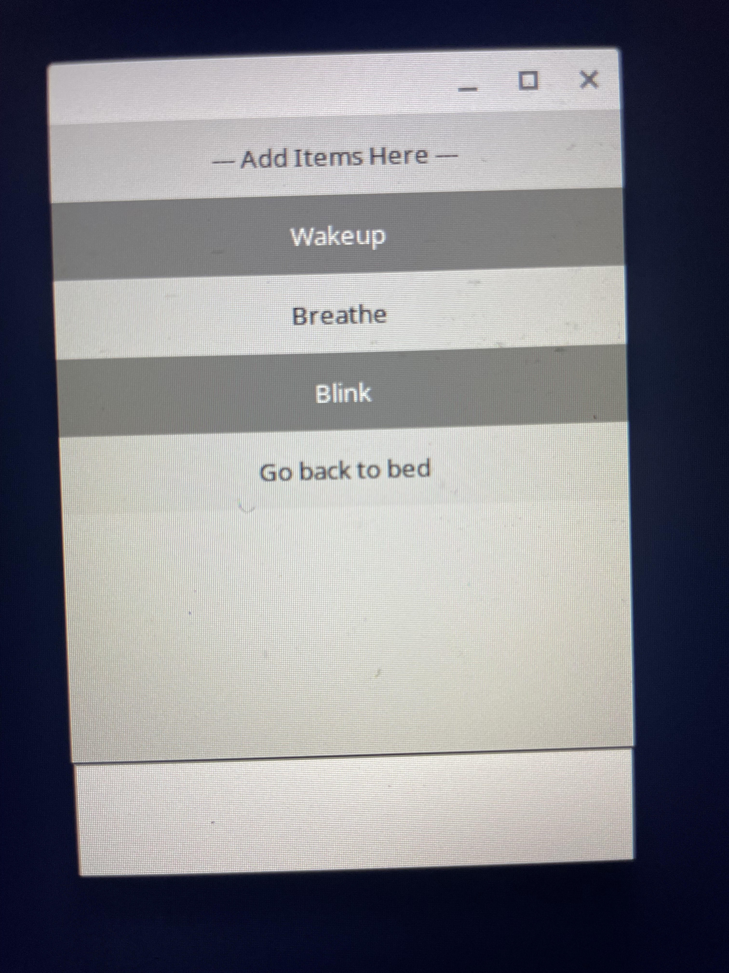

Modified todo app:

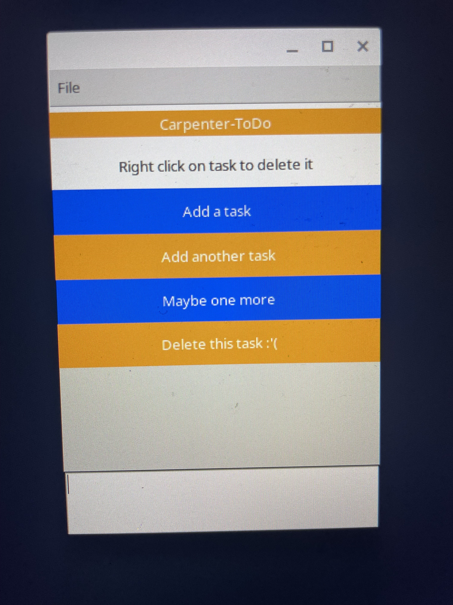

Modified app - removed task:

